

**ELEC362 Assessment 1**

**Ben Hague (201146260)**

**Department of Electrical Engineering and Electronics**

**16 November 2018**

# Abstract

This Report outlines the 2 tasks given in ELEC362 Assignment 1 and discusses the solution to the problem and how the code has been constructed. We then move on to show the testing of the program and how it successfully achieves the specification.

# Declaration

**I confirm that I have read and understood the University’s definitions of plagiarism and collusion from the Code of Practice on Assessment. I confirm that I have neither committed plagiarism in the completion of this work nor have I colluded with any other party in the preparation and production of this work. The work presented here is my own and in my own words except where I have clearly indicated and acknowledged that I have quoted or used figures from published or unpublished sources (including the web). I understand the consequences of engaging in plagiarism and collusion as described in the Code of Practice on Assessment (Appendix L).**

Contents

Abstract 1

Declaration 1

Part 1: A Non-linear Circuit Problem 3

Introduction 3

Program Design 3

Results and Testing 4

Obstacles and Objectives 4

Part 2: Programming Exercise 5

Introduction 5

Program Design 5

Results and Testing 5

Obstacles and Objectives 5

# Part 1: A Non-linear Circuit Problem

## Introduction

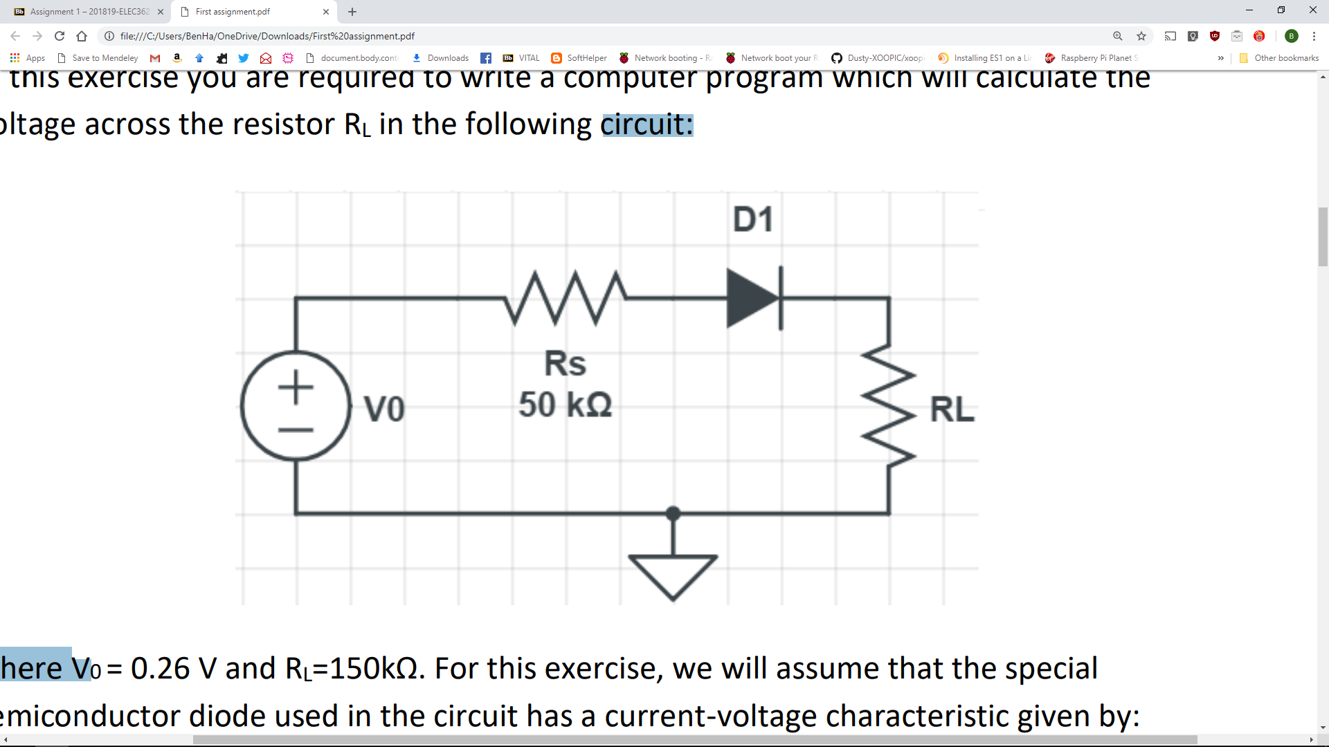The first task is to write a program which will calculate the voltage across the Resistor R­L in the circuit diagram shown in Figure 1. For this process we will be making the assumption that V0 = 0.26v and RL­ = 150 kΩ. we are also going to take the assumption that the special semiconductor diode has a current voltage characteristic given by:

Figure 1: Circuit Diagram for Task 1

$$i=I_{0}\left(\frac{eV_{D}}{kT}-1\right)$$

Where *i* is the diode current and VD the voltage across the diode. e/kT= 40 at room temperature and I = 8x10-8 .

## Program Design

The Program is designed with an object orientated approach. There are 4 object types:

* Diode
* Resistor
* Voltage Source
* Circuit

Below is the class diagram for each key component

|  |  |  |  |  |  |  |
| --- | --- | --- | --- | --- | --- | --- |
| Diode |  | Resistor |  | VoltageSource |  | Circuit |
| private:  double EKT  public: |  | private:  double Resistance  public: |  | private:  double Current  double Voltage |  | private:  double RS  double RL  double V  double I  double EKT  double Precision = 0.0001 |
| private:  public:  double getEKT() |  | private:  public:  double getResistance() |  | private:  public:  double getCurrent()  double getVoltage() |  | private:  double FunctionOfX()  double FunctionOfXD()  public:  double CalculateVD() |

## Results and Testing

As Shown in the Screenshots _____________ we can see that when inputted with ??? we get the result of ??? I have tested this with the results in table ??? which details the output inputs and if the result was as expected

## Obstacles and Objectives

# Part 2: Programming Exercise

## Introduction

The second task of this assignment is to write a program which reads 5 full names from the keyboard, capitalises the first letter of each name and stores the names on a new line in a known file.

## Program Design

The program uses a For loop to record the data and insert it into a new line. During the data collection stage we use a sw

## Results and Testing

## Obstacles and Objectives